**dHF + Citric Acid**

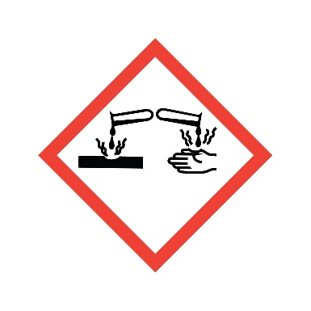

**Danger**

Toxic in contact with skin. Harmful if swallowed.

**Composition**

**1% Citric Acid + dHF (eg 10:1,100:1,600:1,2100:1)**